**Name: Lekha J**

**Roll No. 231047010**

**CAM LAB TEST**

1. FREENAS – WEBDAV

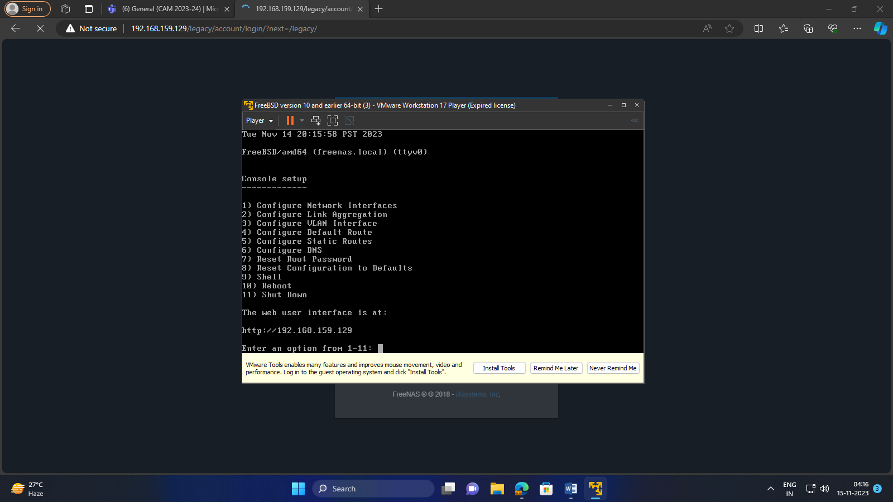

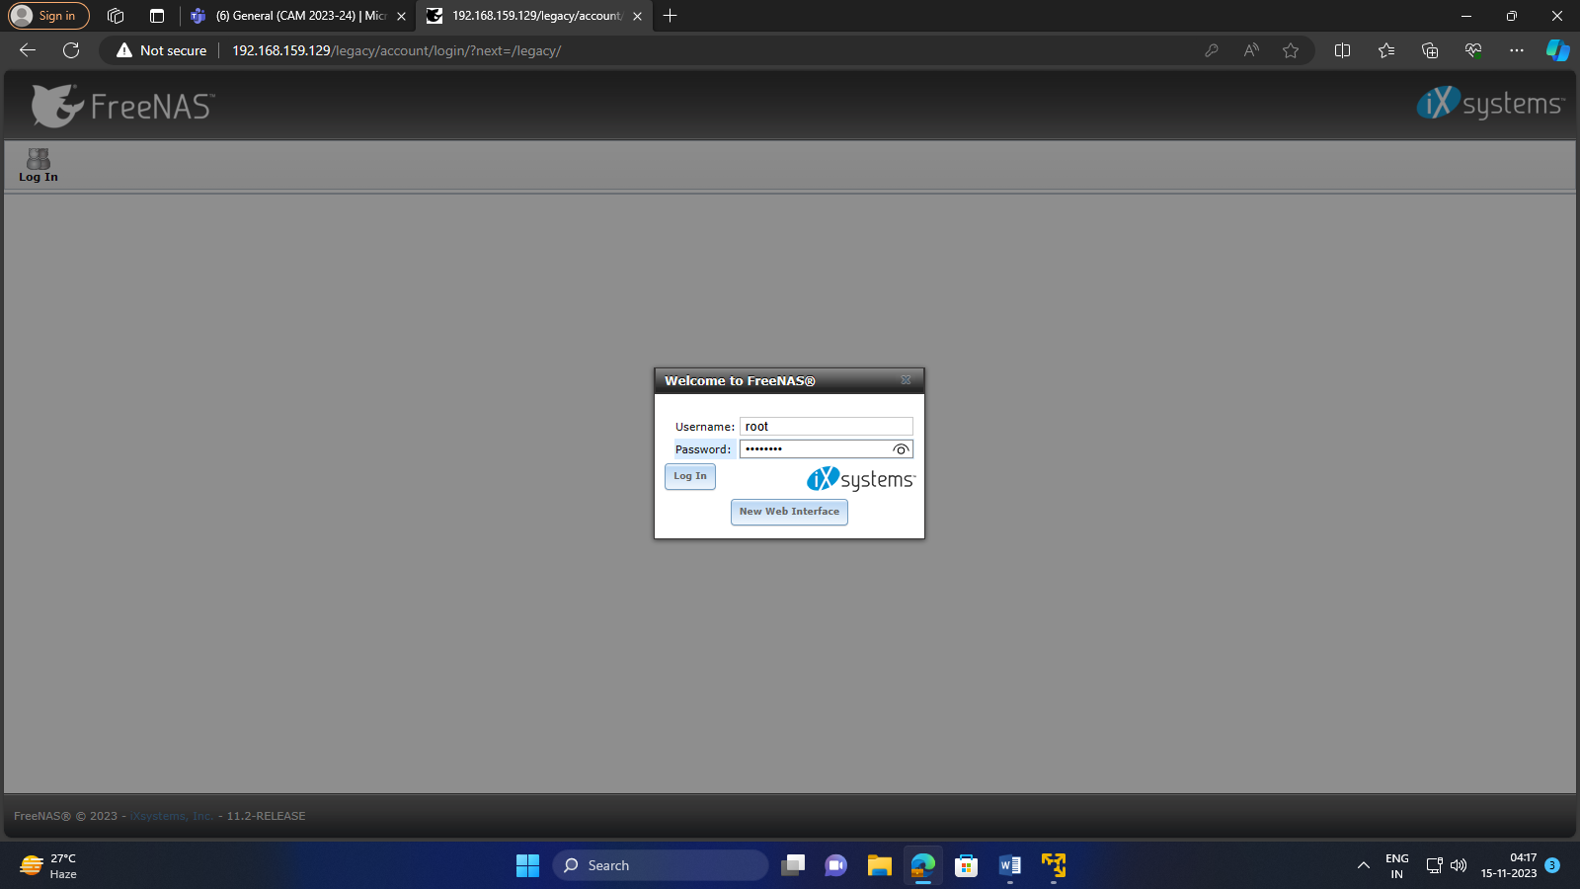

After Log in, go to services and start webdav

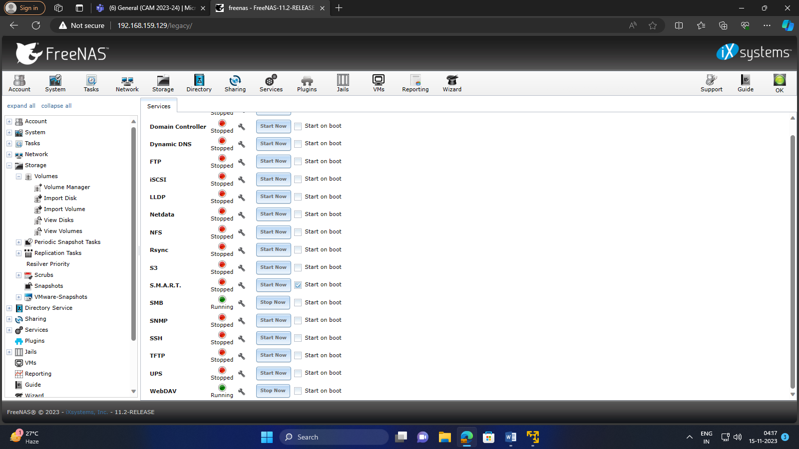

Go to storage and create volume

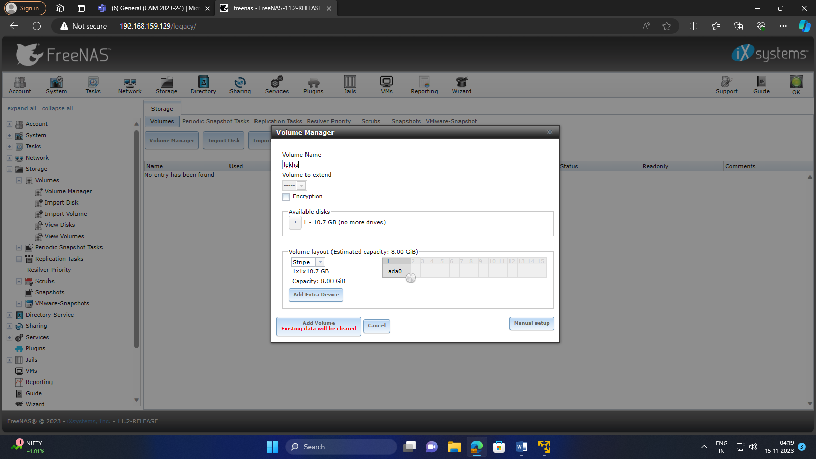

Now go to sharing and create webdav sharing

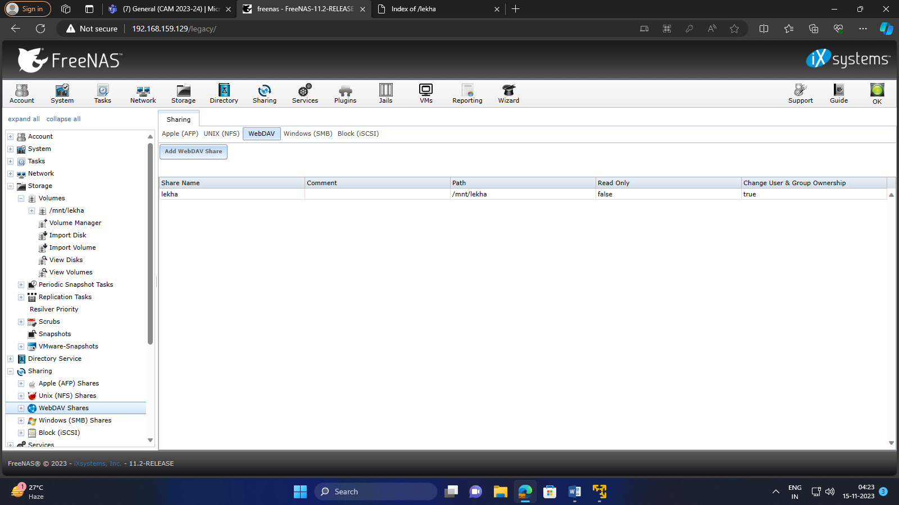

Then in services webdav settings create a digest authentication

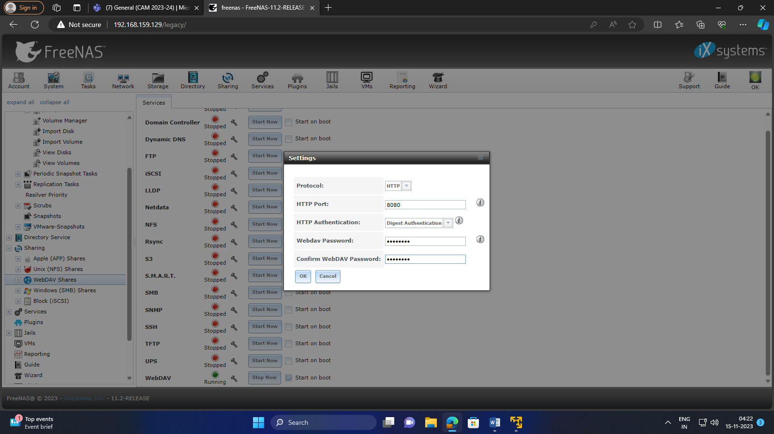

Later, On new browser ip address of freenas with port number you have selected and name of webdav sharing

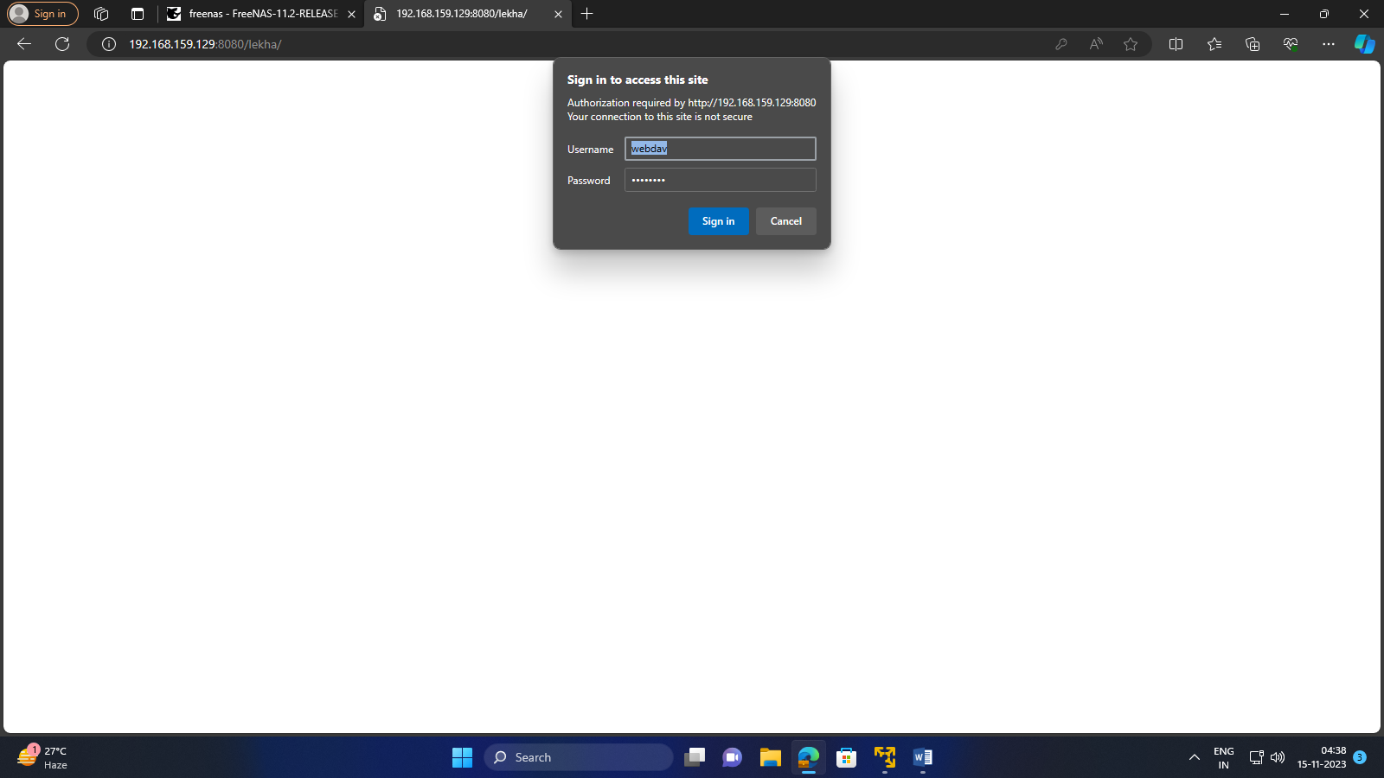

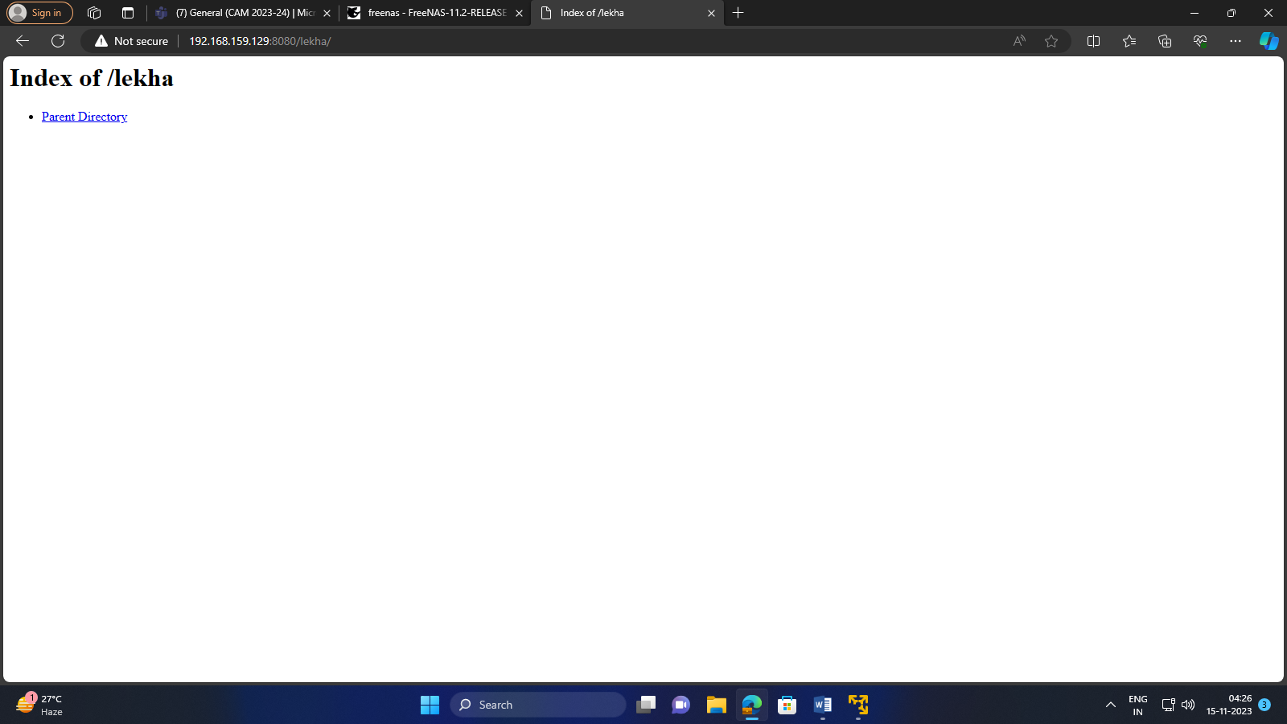

In shell, mount to volume and then create a directory

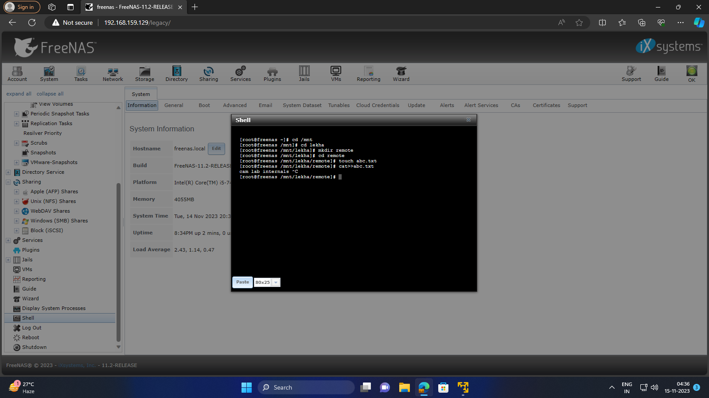

Here you can see the created directory

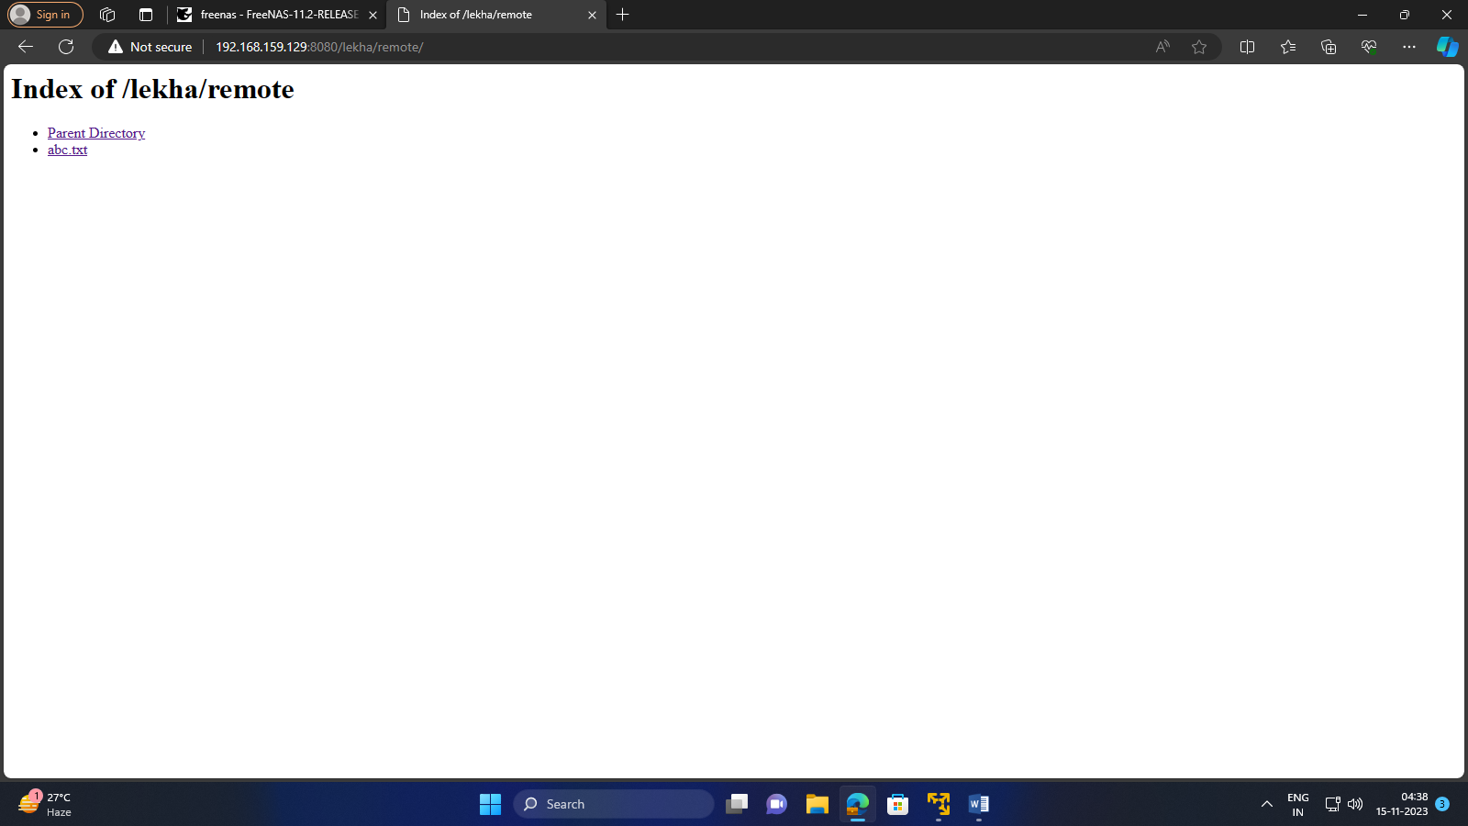

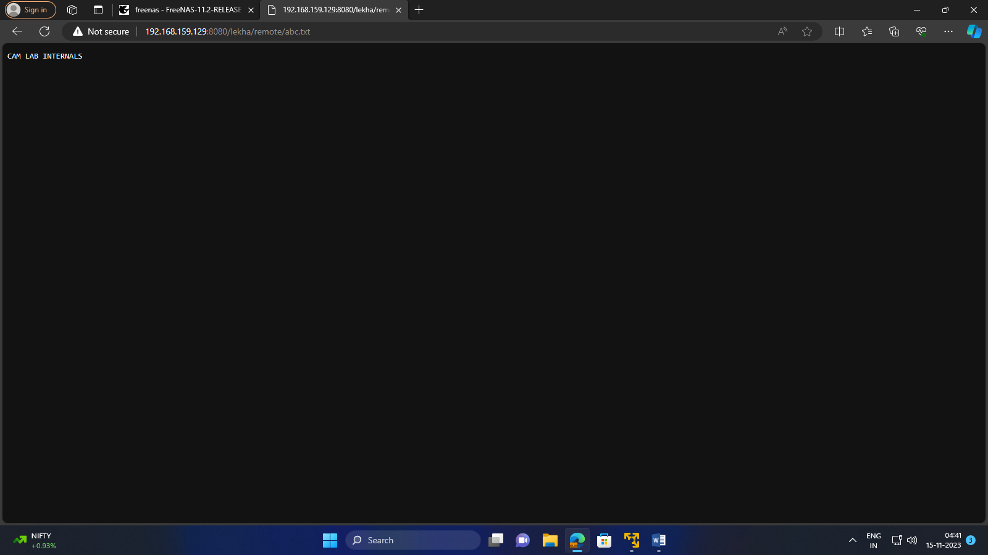

2. MPI CLUSTER PASSWORDLESS SHARING

Install mpi

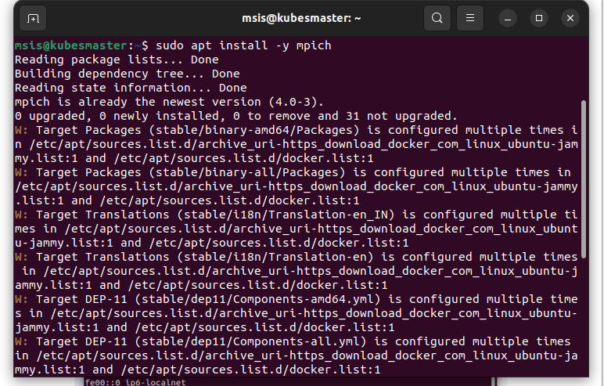

After installation add master and client ip address



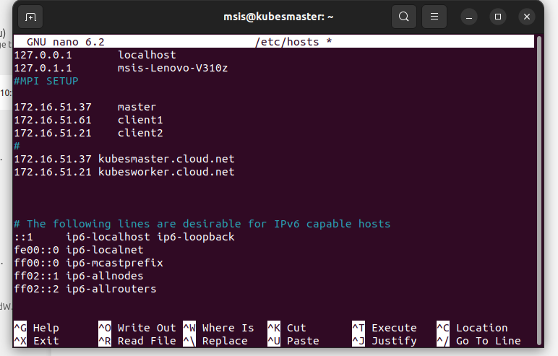

Now add user in both master and slave should contain same name

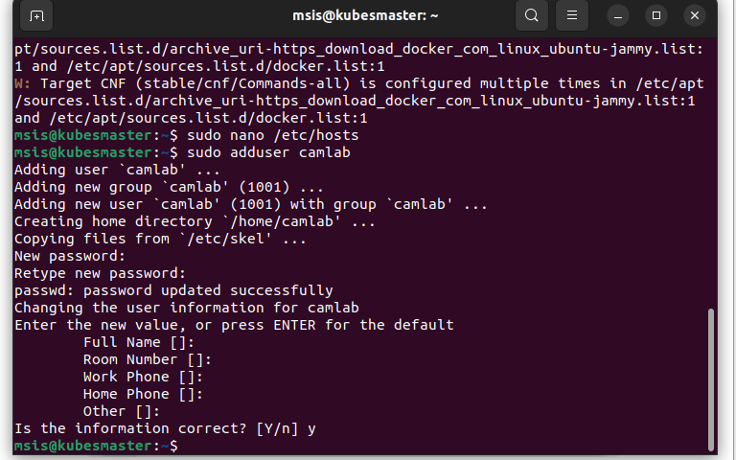

Enter into user you have created and generate the key

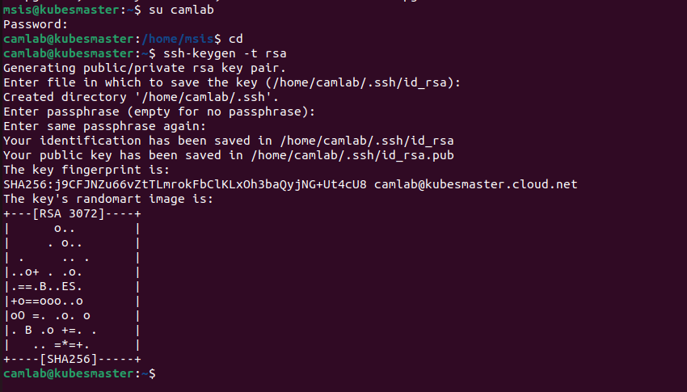

ssh id of client2

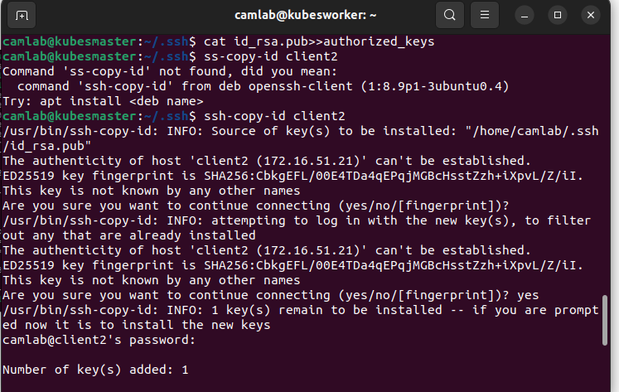

After that come out .ssh directory and enter into client account with user

